ARTICLE 305

Google Authenticator Laptop: Setup, Security, and Troubleshooting
Understanding google authenticator laptop is easier when you separate the concept from the exact interface of a particular service. Most authenticator workflows connect an account to an app, device, or verification method and then request a changing code during sign-in. The process is designed to make unauthorized access harder while still keeping verification fast for the account owner. This article covers the main ideas behind google authenticator laptop, practical setup steps, troubleshooting habits, and safer ways to keep recovery options available before you actually need them.
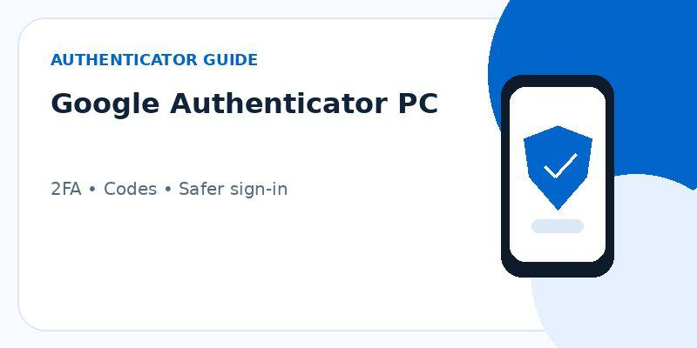

What Desktop or Web Use Really Means
At a high level, google authenticator laptop relates to identity verification rather than to the password itself. An authenticator generally provides a second proof that the person signing in has access to an enrolled device or secret. This matters because passwords can be reused, guessed, phished, or exposed in a data leak. Adding a separate verification step makes a stolen password less useful on its own. The service remains responsible for deciding when the second factor is requested, while the authenticator provides or displays the verification information used to complete that step.

Common Ways to Access Verification Codes
Once setup is complete, the sign-in flow is normally straightforward. You enter the account credentials first and, when requested, open the authenticator to obtain the current verification code. Time-based codes change regularly, so an expired code should simply be replaced by the next current code rather than reused repeatedly. If google authenticator laptop involves a different platform or device, the principle is still the same: make sure the account is enrolled correctly, verify one code successfully, and only then rely on the authenticator as part of your normal login routine.
There is no need to force a mobile workflow into a browser if the service already supports another approved second factor. For google authenticator laptop, compare the options shown in the account's security settings, such as an authenticator, security key, passkey, trusted-device prompt, or backup codes. Choose the method that fits the device you actually control and understand how recovery works before making it the only second factor on the account.
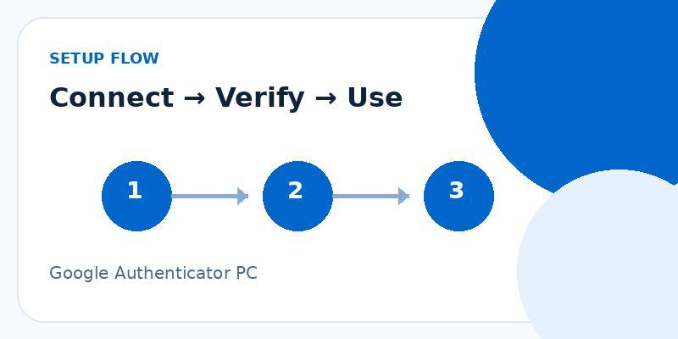

Setup Considerations Before You Start
Before making changes, check that you can still sign in to the account and that at least one recovery path remains available. This is especially important when moving to a new phone, removing an old authenticator entry, or changing the second-factor method. For google authenticator laptop, a safe sequence is to add or verify the new method first, test it in a separate sign-in session, and only then remove an older method if you no longer need it. That order reduces the chance of creating a lockout while the account is in transition.

Security Risks on a Computer
A lost device or deleted authenticator entry is a different problem from an invalid current code. In that situation, the priority is account recovery rather than code troubleshooting. Use the recovery method previously provided by the service, such as backup codes, an approved device, or the account-recovery flow. Do not remove working security methods until access is restored and a new authenticator is confirmed. For google authenticator laptop, planning recovery in advance is one of the simplest ways to avoid turning a minor device problem into a long account-access problem.
There is no need to force a mobile workflow into a browser if the service already supports another approved second factor. For google authenticator laptop, compare the options shown in the account's security settings, such as an authenticator, security key, passkey, trusted-device prompt, or backup codes. Choose the method that fits the device you actually control and understand how recovery works before making it the only second factor on the account.
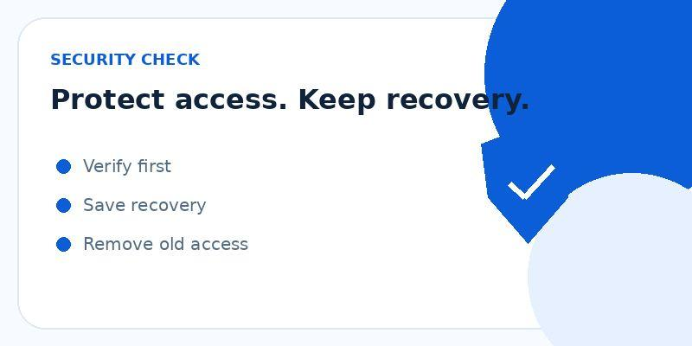

Practical Recommendations for Daily Use
Good authenticator hygiene is mostly about keeping control of enrollment and recovery. Protect the phone or computer with a screen lock, install authenticator software from a source you trust, and review the account's security settings from time to time. If a service offers recovery codes, store them somewhere separate from the device that generates your normal codes. This approach makes google authenticator laptop more resilient because a single lost or damaged device does not automatically remove every route back into the account.
Users should also be cautious with screenshots and screen recordings. A setup QR code, manual secret, recovery code, or live verification code can reveal more than an ordinary app screenshot. When documenting a problem, crop or blur sensitive information and never post enrollment material publicly. This is particularly important when asking for help in forums, social media, or support chats, where images can be copied and viewed by people who do not need access to the account.
One final check is to review the account after a successful sign-in. Make sure the active methods shown in security settings match the devices you actually control. Remove an outdated method only after you have verified a replacement. This small review is useful because old enrollment entries can remain active long after a device has been replaced. Keeping the list current makes future troubleshooting faster and makes it easier to recognize an unfamiliar method that should not be there.

Final Thoughts
In practice, google authenticator laptop is easiest to manage when you treat setup, verification, and recovery as one connected process. Use the protected service's official security settings, confirm a new method before removing an old one, and keep at least one independent recovery option available. A current authenticator code should never be shared with someone who contacts you unexpectedly, even if they claim to be support. With a tested setup and a simple recovery plan, an authenticator can add meaningful protection without making everyday sign-in difficult.
For a simple overview of authenticator-based protection, you can also visit the authenticator App site for additional product information.
If you use iPhone and want the app-store version, you can download authenticator App from the official App Store listing.
Keyword: google authenticator laptop • Approx. word count: 993

